RHODE ISLAND CONSTRUCTION TRAINING ACADEMY

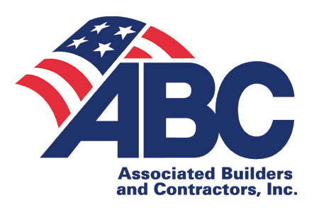

APPRENTICESHIP REGISTRATION
2018/2019
COURSE INFORMATION
STUDENT INFORMATION

______________________________________
Name: First M. Last

_____________________________________________
Mailing Address

_____________________________________________
City State Zip Code

______________________/_______________________
Day Time Phone / Cell Phone Number

______________________________________
E-Mail Address

_____________________________________________
Signature Date
APPRENTICE SPONSOR COMPANY INFORMATION

_____________________________________________
Company Name

_____________________________________________
Mailing Address

_____________________________________________
City State Zip Code

_____________________________________________
Phone Number Fax Number

______________________________________________
Email Address

______________________________________________
Contact Person

______________________________________________ Signature Date
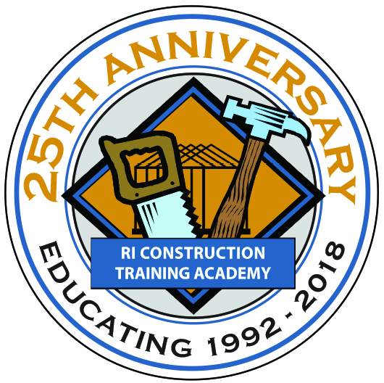

________________________ 1 2 3 4 5
Course Name Level

License Acquiring : ○Journeyman II or ○ Journeyman I
Years You’ll Be Attending RICTA 1 2 3 4 5

TUITION INFORMATION

ABC of RI Member in good standing….$ 950.00
Non- Member ABC………………….... $1450.00
Course Book (required)……….………..$ 145.00
Processing Fee………………………….$ 100.00

Who is responsible for tuition? Circle & write amount
company _______student _______other___________

Tuition MUST be paid in full BEFORE classes begin.

Payment Enclosed (circle one)
Cash * Check * Mastercard * Visa

Card #______________________________________
CVC Code____________Exp Date_______________
Card Billing Address: _________________________
___________________________________________
Authorized Signature: _________________________

Make checks payable to RICTA or RI Construction Training Academy.

A separate registration must be completed for each course level and must be accompanied by tuition. The $100 processing fee is non-refundable unless RICTA cancels the course, in which case full refund will be mailed. By signing this form you agree to RICTA policies, which can be found on our website www.ricta.org.

249 Roosevelt Avenue, Suite 203, Box 4, Pawtucket, RI 02860
EDUCATING
1992 - 2017
Kristen@ricta.org Phone 401-305-3510 Fax 401-305-3540
Rhode Island Construction Training Academy affiliated with
Associated Builders and Contractors, Inc. Rhode Island Chapter
R.I.C.T.A. does not discriminate in admissions, recruitment, services or employment on the basis of sex, race, color, religion, national origin, ancestry, sexual orientation, age or handicap.

